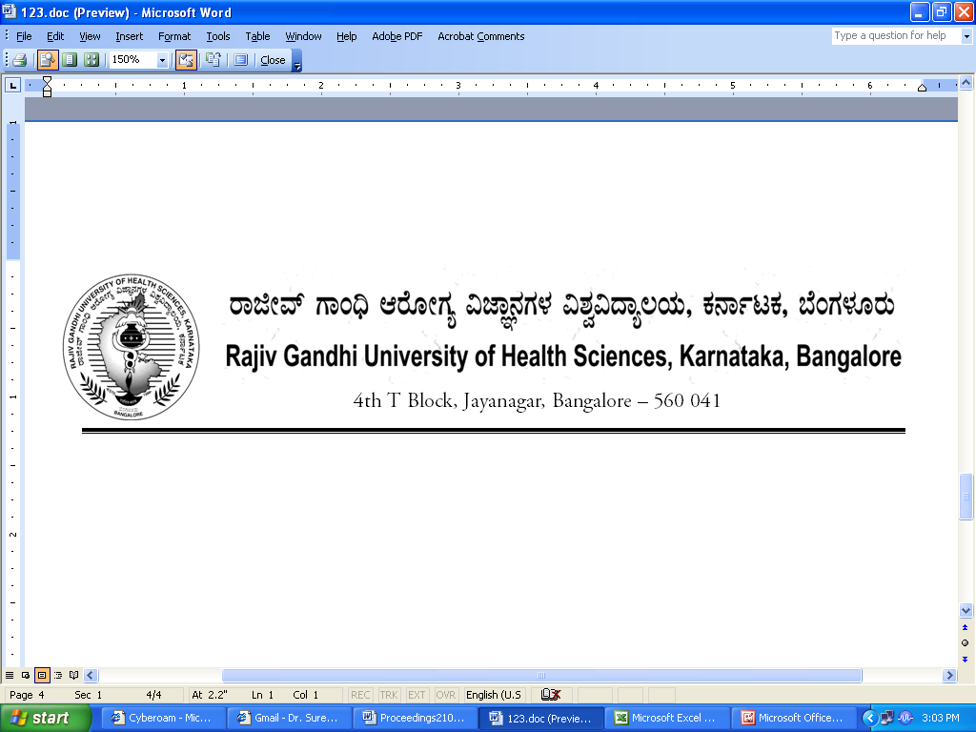
Reg(E)Exam/UG/April/May - 2018 Date: 03/01/2018

Advance Notification

Sub:- | Conduct of B.Sc Nursing and P.B B.Sc Nursing (UG) and B.P.T Courses Theory Examination during April/May - 2018.
********

The B.Sc Nursing and P.B B.Sc Nursing and B.P.T Theory Examination for the below mentioned courses will tentatively commence from 02nd April 2018. The detailed Time Table will be notified in due course.

 | Courses | Date
1. | B.Sc Nursing and P.B B.Sc Nursing | 02nd APRIL 2018
2. | B.P.T | 02nd APRIL 2018

The Principals of the concerned Colleges are requested to notify this on the Notice Board of their colleges for information of the students concerned.

Sd/-

Registrar (Evaluation)
To:
All the Principals of the colleges concerned for information and needful action.
Copy to:

- PA to Vice-Chancellor/Registrar/Finance Officer, RGUHS, Bangalore.
- Deputy Registrar (Admn) section for information and needful action.
- All the officers of the RGUHS, Bangalore.
- Asst. Registrar, Regional Center, Belgaum / Gulbarga.
- Guard File.

